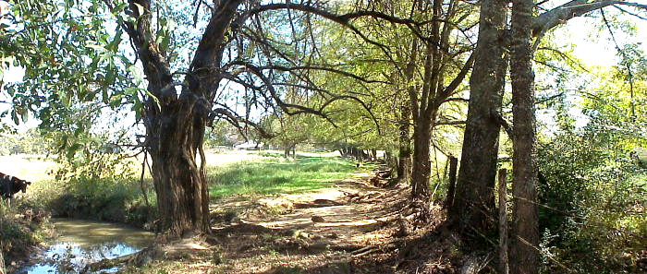

Ode to a Bois d'Arc

You were bow wood for the Osage and the Caddo, two hundred years ago,
You are old and gnarled and knotted and forever thus you have been so,
On the bank of Little Sandy Creek you grow, in a meadow you don't share,
No one on purpose planted you, it's just by chance and fate you're there.

Your age has not brought you fame, like the San Saba Mother Pecan,
The Hopewell Magnolia or the Austin Treaty Oak where Texas began,
The Star Ridge Blackjack, and the Lake Franklin Sassafras are better known,
Even the Winchester Square Mulberry, though they're all now long since gone.

Bitter is your wormwood sap; your tough orange heart bends but never breaks,
Green horseapples your worthless fruit, your sparse leaves a poor arbor makes,
No critters nest in your wiry branches, for there they find no natural cover,
But old barbwire fence builders know, your crooked fence posts last forever.

As trees go, you are nothing special, to anyone but me that's still around,
But on an August morning long ago, your shade became my Holy Ground,
I was just a half-grown barefoot boy, when the Lord spoke sweet peace to me,
There is no altar there, just you, my silent sentinel, witness to my testimony.

So, my homely Bois d'Arc, of all the trees that ever grew, I love you most of all,
You've marked the seasons of my life, near spent now as winter follows fall,
Like me, you bear the scars of life, from battles that you've had to fight alone,
I've told your tale, now you tell mine, for you will still be there long after I am gone.

Barto Fanning @ June 28, 2006

